MINET RAI on our project about minorities – broadcast on November 17th, 2021

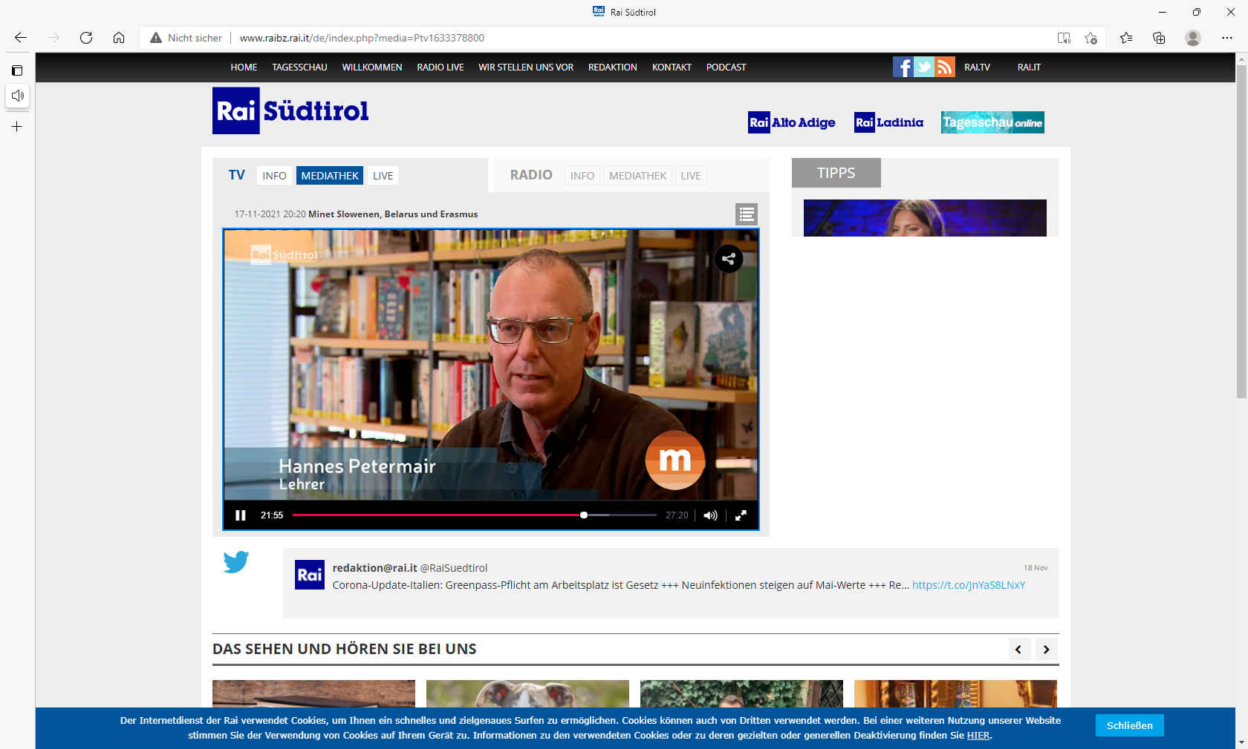

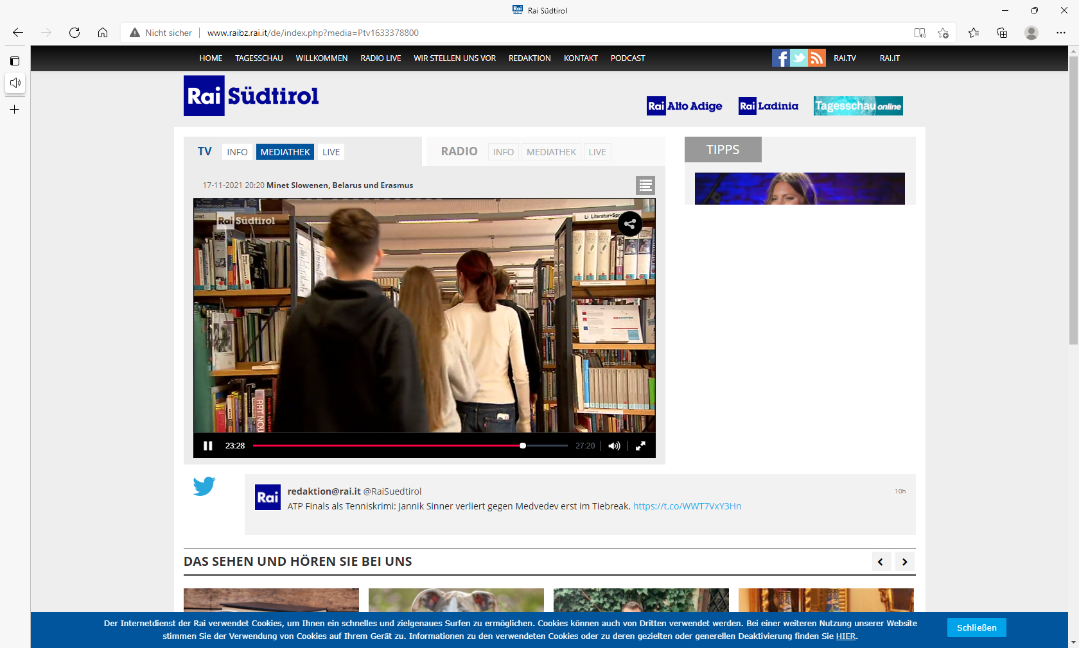

On Wednesday, 17th November 2021 our national TV company through its local channel (RAI Südtirol) broadcast a short report on our current project. The program is called “Minet – minorities in Europe” and obviously, deals with minorities within the old continent.
The above-mentioned episode dealt with a Slovenian school in Klagenfurt, a TV channel in Belarus and an Erasmus+ project on the diversity of minorities.
“(Un)recognised Diversity: Minorities in Europe” is the title of the Erasmus+ Project even the Classical Gymnasium in Bozen is taking part in. The Covid-19 has made the execution of the project almost impossible.
Inside its rubric “Minorities Telegram” Minet reports and discusses current topics throughout Europe. The program is produced in collaboration with the local Eurac’s Institute for Minority Rights, and supported by the regional Center for Linguistic Minorities.

